**LIT ASSIGNMENT-DAY 14**

**NAME: CHIKATI LIKHITHA**

**EMPLOYEE ID: 46255243**

**BATCH NAME: SAP ABAP-25**

**CDS-Assignment 1** – Create a Simple CDS view with Date Functions in ABAP CDS Views.

**STEP1: Created a Simple CDS view:**

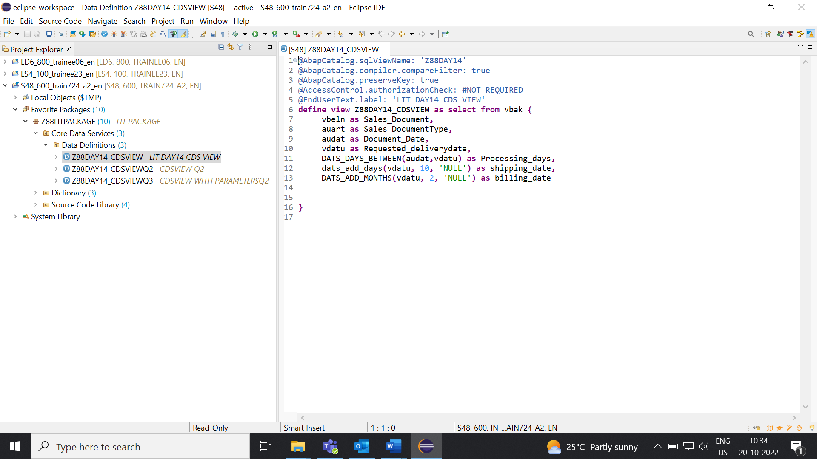

**STEP2: Output.**

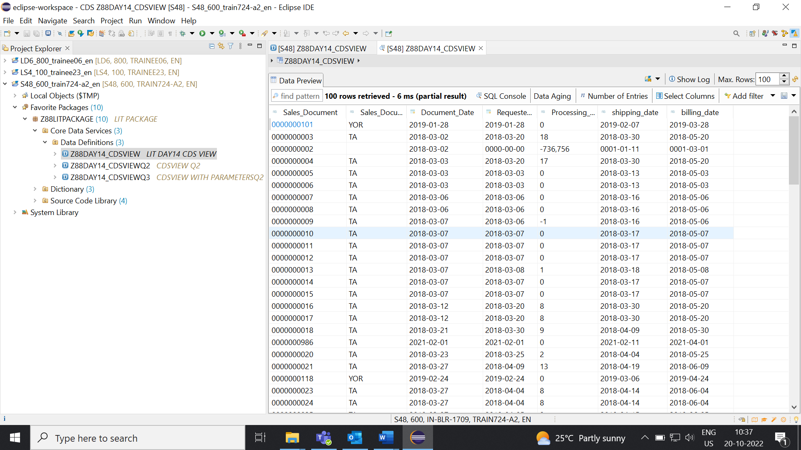

**CDS-Assignment 2** – Create a Simple CDS view with string functions in ABAP CDS Views.

**STEP1:** Code

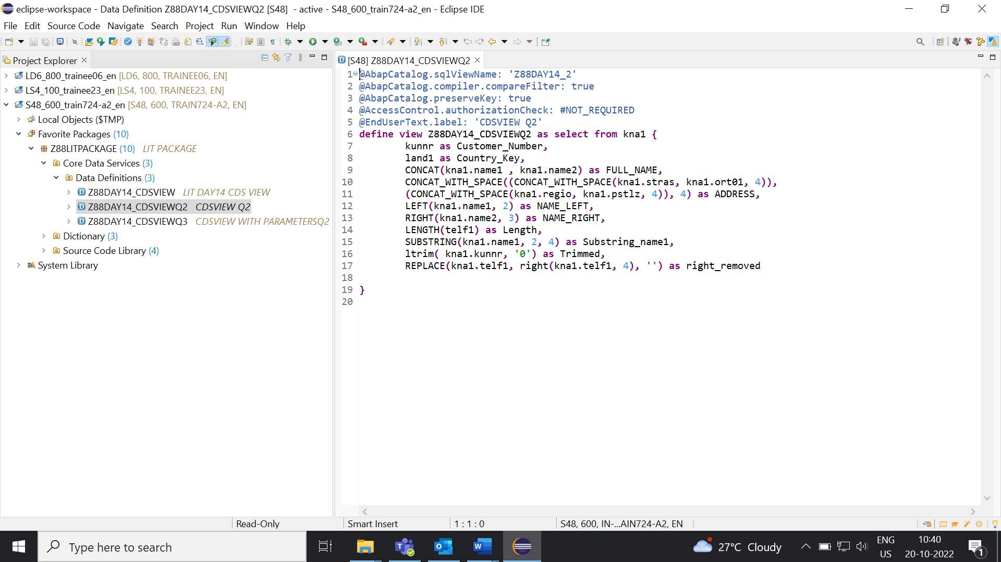

**STEP2:** Output

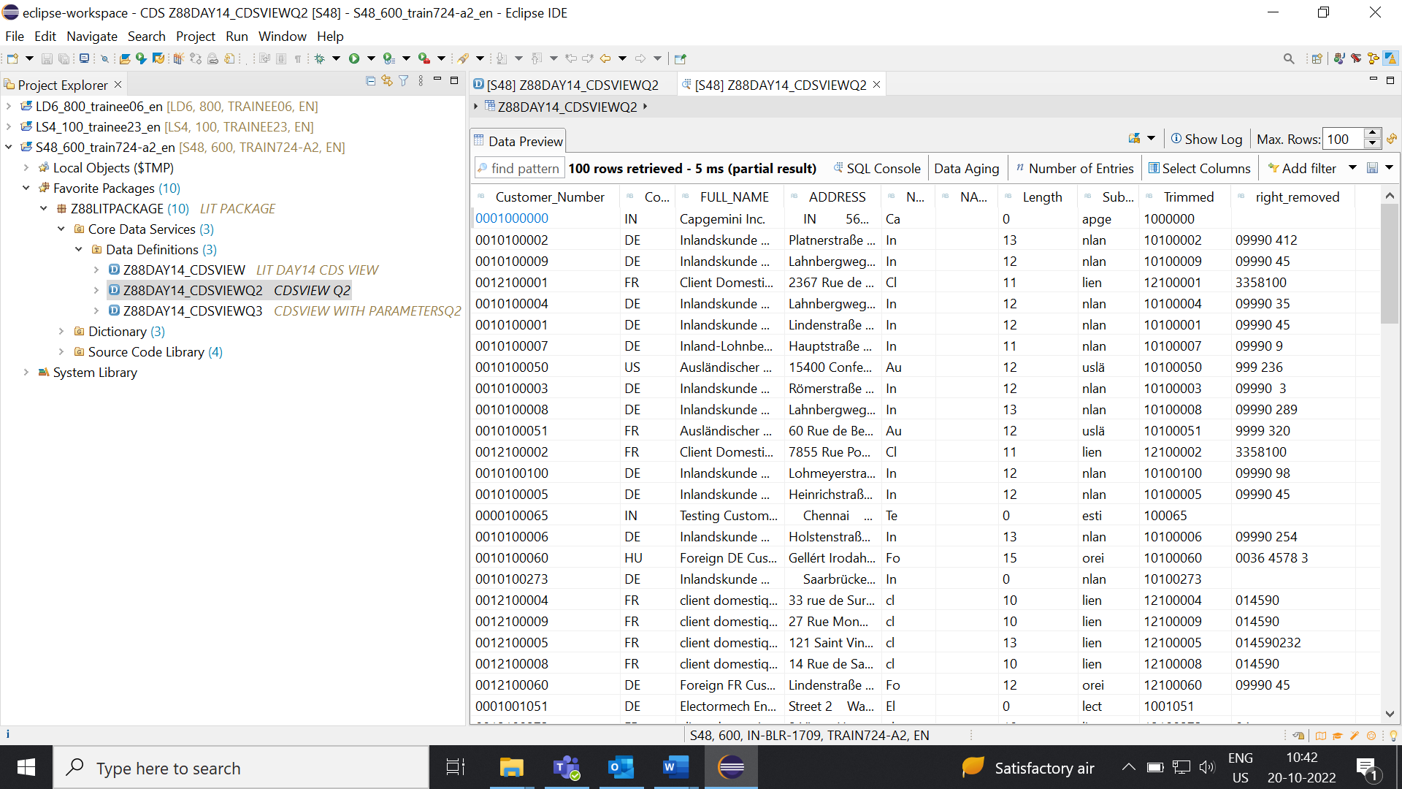

**CDS-Assignment 3** – Create a Simple CDS view with Parameters.

**STEP1:** Code

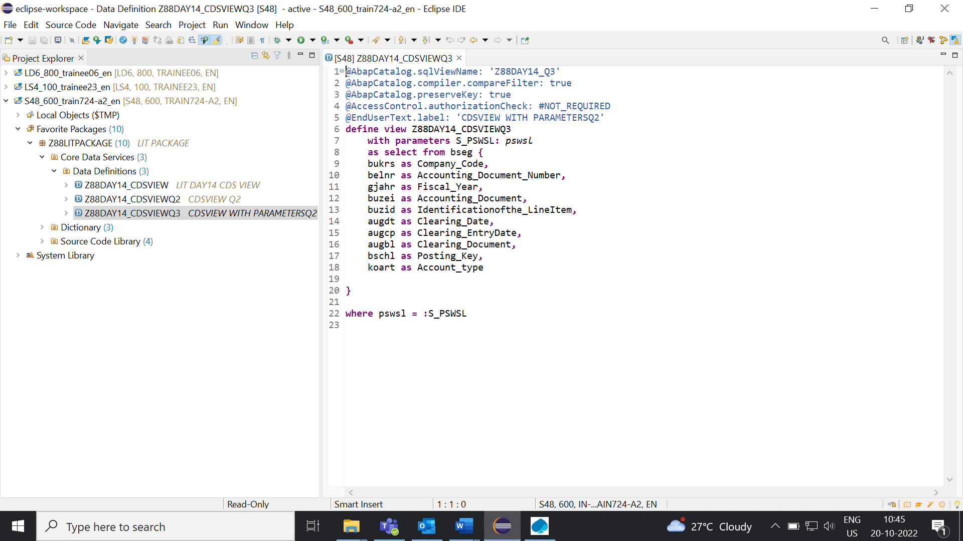

**STEP2:** Enter PSWSL

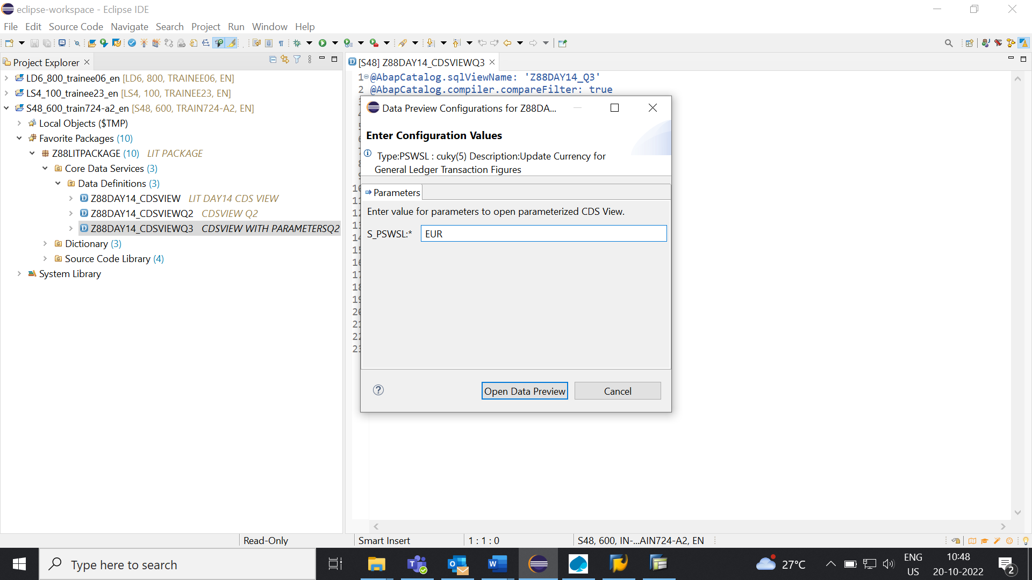

**STEP3:** Output.

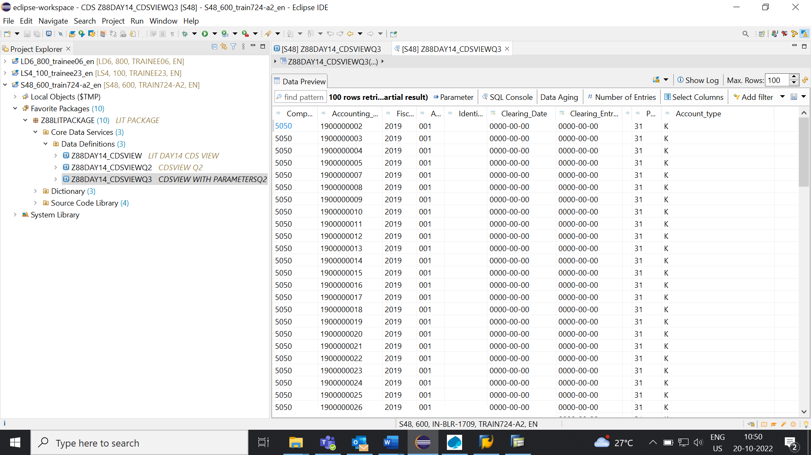

**AMDP-Assignment 1** – Procedures - create a basic procedure to fetch data with scalar variable.

**STEP1:** Create a Class.

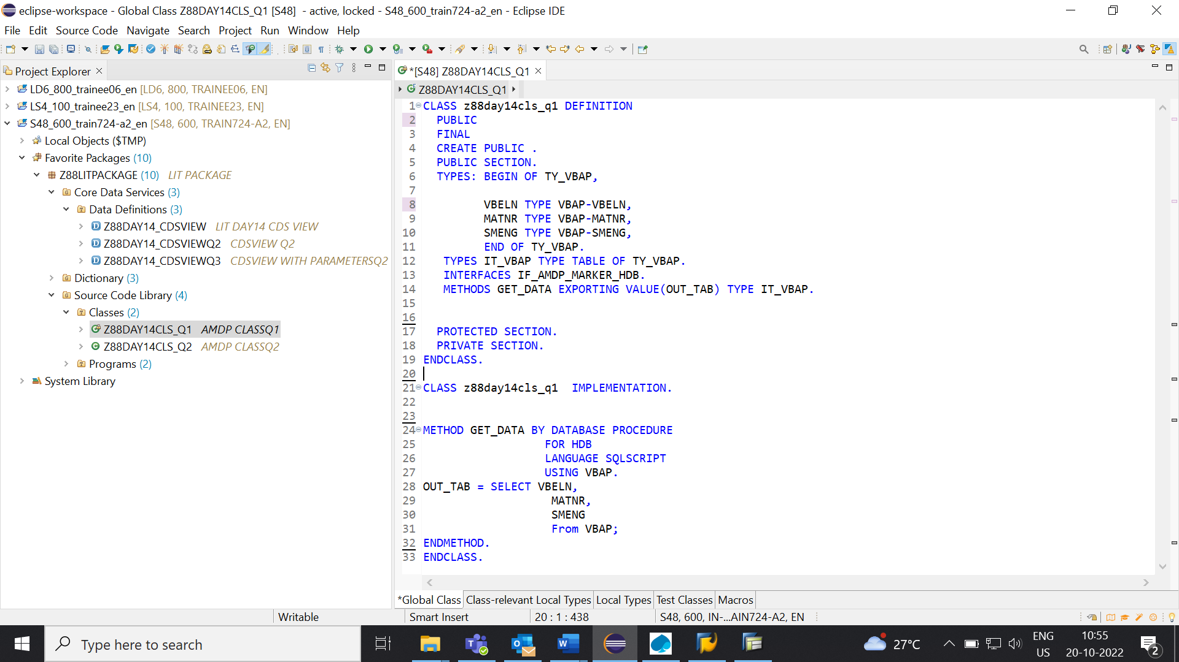

**STEP2:** Create a Program.

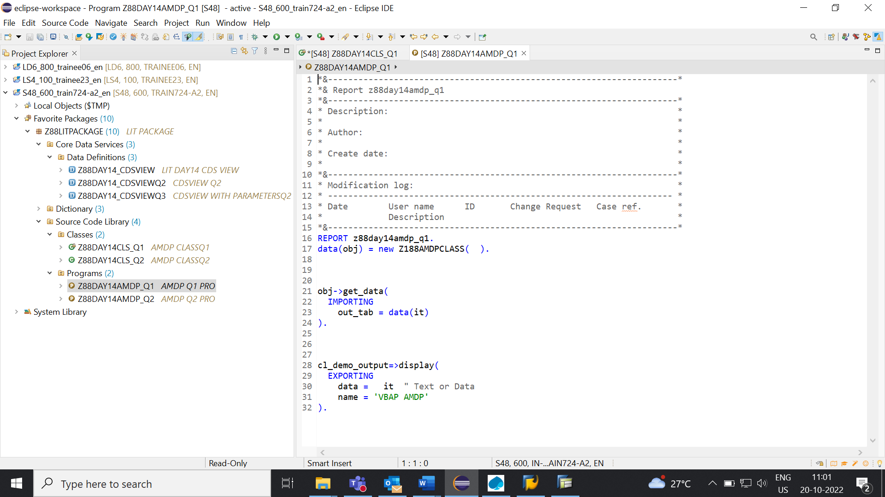

**STEP3:** Output.

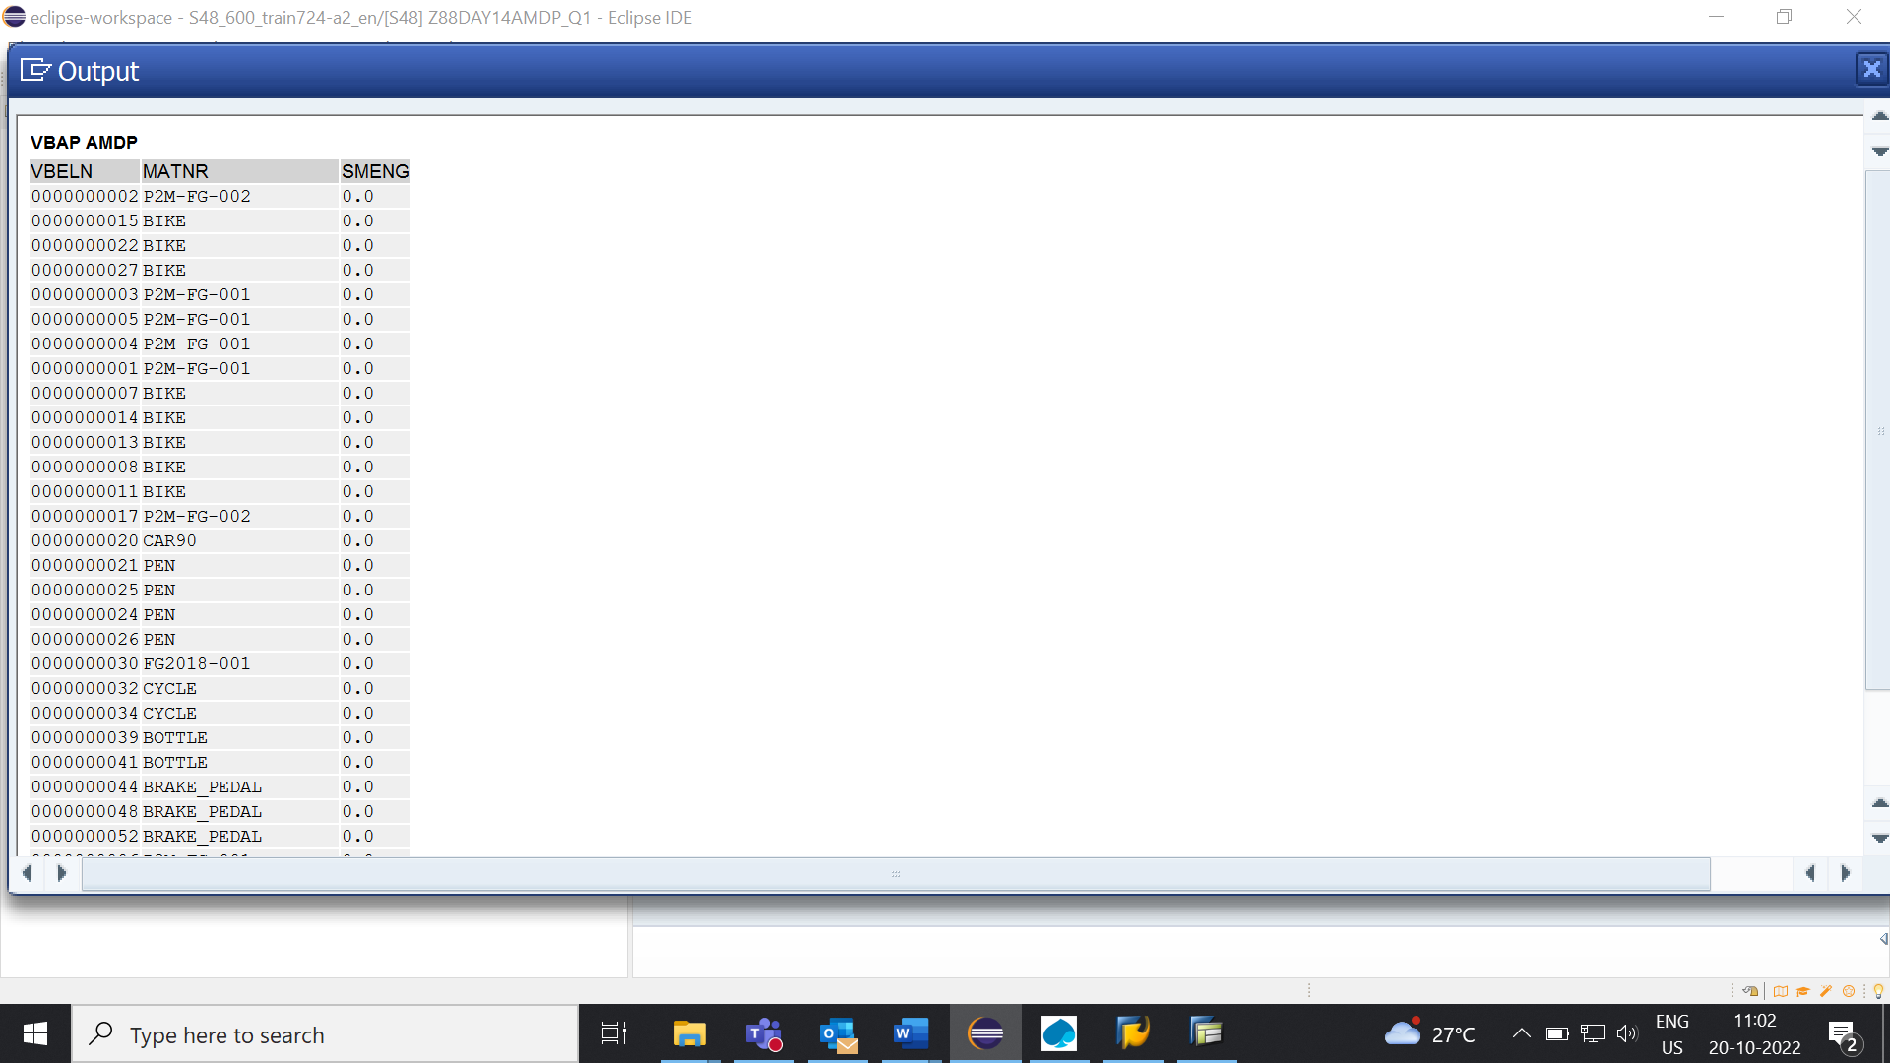

AMDP-Assignment 2 – Procedures - create a basic procedure with Table.

**STEP1:** Class.

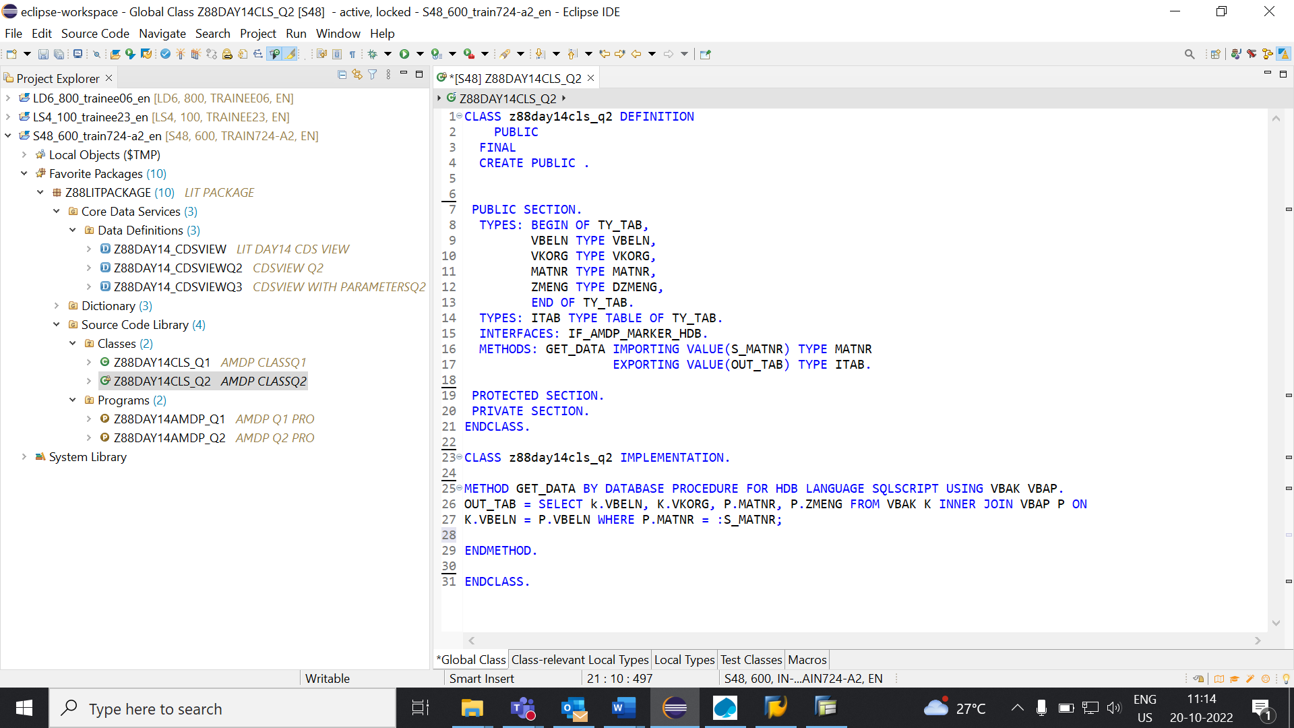

**STEP2:** Create a Program.

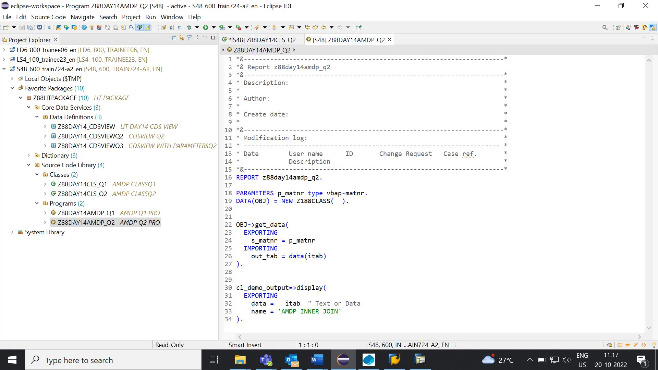

**STEP3:** Enter MATNR.

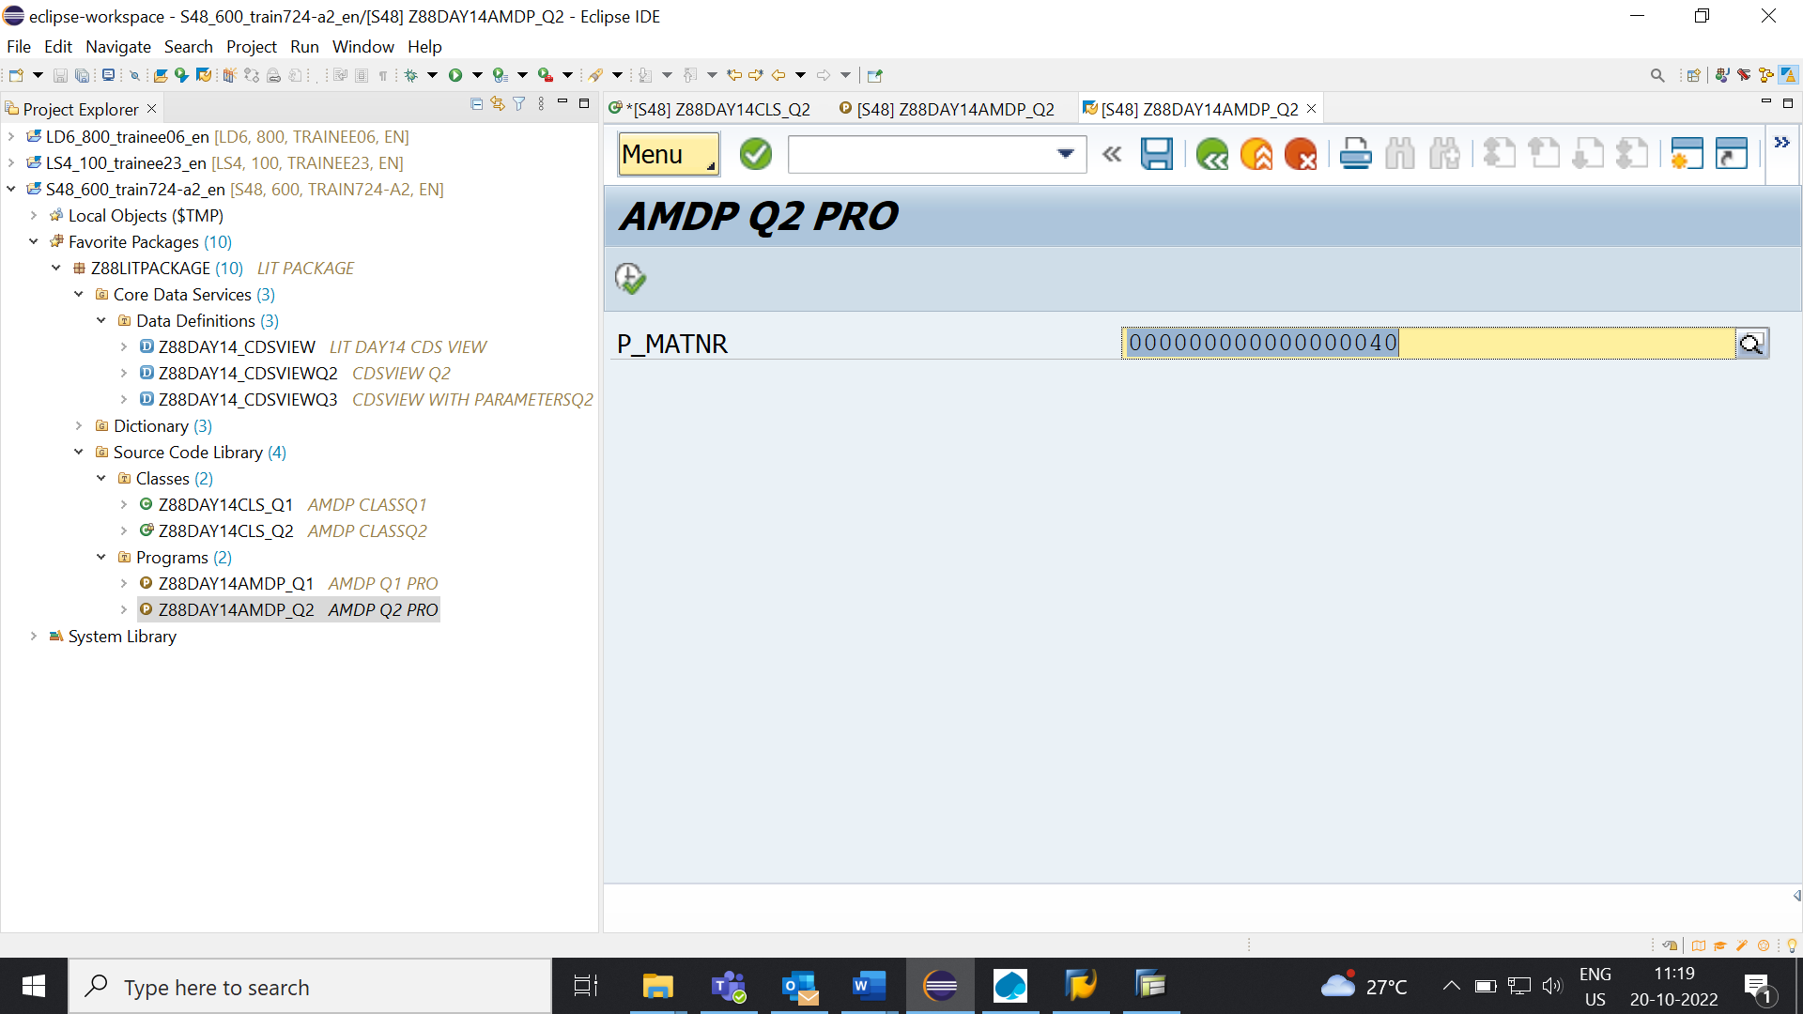

**STEP4:** Output.

